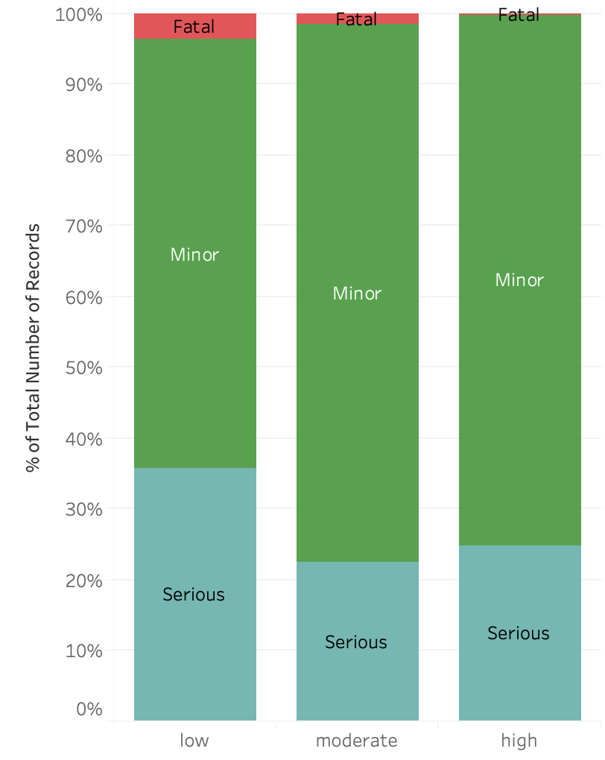

Poor Visibility Days are when Road Fatalities in Senior population is availability

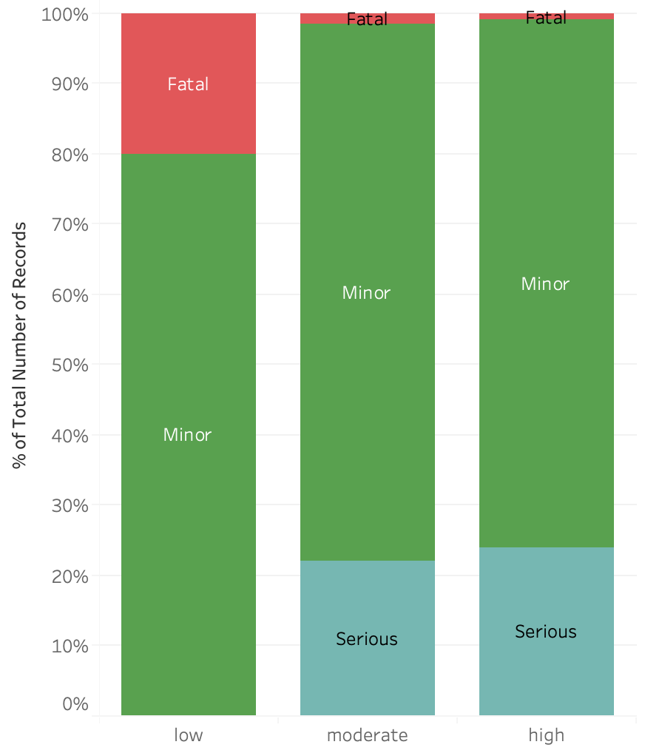

Poor Road Conditions are tied with Increased Fatalities

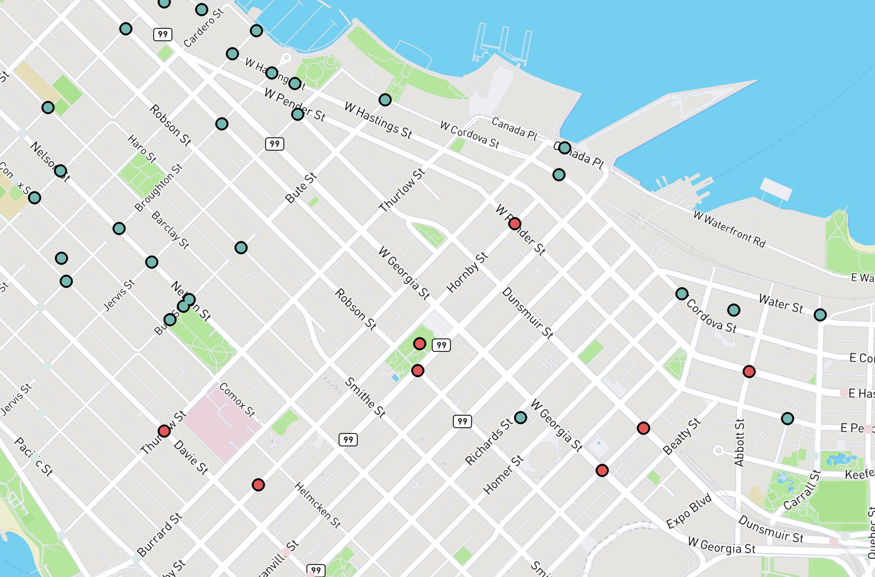

Red Dots are Fatal incidents involving Seniors and Green Circles are where Road Safety features are installed : Stop Signs, Zebra Crossing, Special Crossing, Speed Bump, Parallel Lines

